Prescribed moorland burning meets good practice guidelines: a monitoring case study using aerial photography in the Peak District, UK

Katherine A. Allen, Pierre Denelle, F.M. Sánchez Ruiz, Victor M. Santana, Rob H. Marrs

School of Environmental Sciences
University of Liverpool
Liverpool L69 3GP

Introduction

Upland moors in the UK have been managed for centuries using rotational prescribed-burning, but in recent years there has been contentious debate over its continuing use due to varying effects on moorland ecosystem services (Tucker 2003; Bain et al., 2012). Prescribed-burning should only be carried out using good-practice codes, which include restrictions on the size, location and frequency of burns. Surprisingly, there is little information about the scale and extent of prescribed-burning over time. In Scotland, an historical comparison (1940s -1980s) of burning across two areas showed clear geographical differences, with no burning at seven out of 32 sites in the southern sample area (Borders) yet only one of 32 in the northern area (Grampians) (Hester and Sydes 1992). They showed that mean areas burned were similar in each region and that there was no evidence of a decline in burning activity since the 1940s. They also reported burning rates far below the ‘optimum’ (every 10-15 years) advised by the Muirburn Working Party (1977). In the English uplands, Yallop et al. (2006), also using aerial photography, provided an overall baseline assessment of burning activity of the English uplands in 2000. They showed that 17% of ericaceous-dominated moorland (mainly Calluna) had been burned within the previous four years, with a median repeat burn time of 20 years. They also suggested an increase in area of very recent burns in a sub-set of sites within English National Parks from 15.1% to 29.7%.

Given the contentious nature of the use of prescribed fire, it is surprising that there has been little attempt to assess management performance. Here, therefore, we investigated the use of prescribed-burning on a single case-study estate (Howden Moor) in the Peak District National Park, Derbyshire over a 22-year period. Specifically we assessed whether prescribed-burning was producing: (1) burns covering agreed proportions of the moor, i.e. appropriate rotation lengths, and (2) small burns of an appropriate size. We also assessed the probability of a very large escape fire being produced. We did this by identifying and digitising the outlines of all the prescribed-burn patches on the estate using a combination of management maps, corroborated with aerial photography for 1988-1998, and aerial photography for the 2001-2008 period. The number and area of burns were then calculated for each of the time periods.

Methods

This study was carried out at Howden Moor, Derbyshire, UK, which is dominated by Calluna vulgaris-Eriophorum vaginatum communities (M19/20 within the UK’s National Vegetation Classification), growing on Blanket Bog. We assessed prescribed-burning between 1988 and 2009 using a combination of detailed estate burning maps and aerial photography within a Geographical Information System (GIS). The following information was then extracted from the GIS for each period:
- Number of burn patches.
- Area of each burn patch.
- Overlap of burn patches in different time periods, indicating multiple fires at a single location. These areas are hereafter referred to as “repeat-burned areas”.

We then calculated both the ‘sum of burn patch areas’ across all years (including repeat-burned areas additively) and the ‘area exposed to burning’ across all years (representing the area of ground burned at least once during the entire study period, irrespective of the number of successive burns at any one point). The area of prescribed-burns in each period was also calculated as a percentage of both the entire moor area, and the area that was deemed “potentially burnable”. The “potentially burnable” area excludes parts of the moor where prescribed-burning was unlikely to be used; i.e. because of their topography (valley sides), substrate (rocky outcrops), or vegetation composition (protected habitats, areas dominated by graminoids and subject to ongoing restoration work).

Results

The distribution of all prescribed-burn patches in relation to the entire moor and the “potentially-burnable” area is shown in Fig. 1. Over the 22-year period 4.16 x 10⁶ m² was burned at least once, equating to 20% of the entire moorland area or 29% of the “potentially-burnable” area (Table 1); i.e. 80% of the entire moor area or 71% of the “potentially-burnable” area. The sum of all burn patch areas (including repeat-burned areas) was 5.37 x 10⁶ m². The annual area burned fluctuated between 0.10-0.34 x 10⁶ m², with greatest activity between 2006 and 2009 when ca, 1.4 x 10⁶ m² was burned in total (Table 1a). This equates to between 0.5 and 1.6% of the entire moor area per year or between 0.7 and 2.4% of the “potentially-burnable” area per year (Table 1b).

In total, 2561 prescribed-burn patches were detected, with the greatest number found between 1991 and 1995 (716 patches) and between 61 and 555 prescribed-burn patches in the other time periods (Table 1a). The mean (± se) patch size over the entire 22-year period was 2098 ± 67 m² (Table 1a), but the size-distribution was skewed heavily towards small patches (Fig. 2). Nevertheless, there were some patches in each time period that were much larger than the mean, with the largest one at almost 109,718 m² between 1988 and 1990. Since this early period the maximum size has reduced with only three burn patches identified greater than 20,000 m²; two between 2003-5 (37,880 and 36,478 m² ) and one between 2008-09 (34656 m²). Thus, the maximum patch size has reduced by 68% over the study period.

Some areas were burned more than once during the study period (repeat-burned areas); in total 0.96 x 10⁶ m² was burned twice, 0.13 x 10⁶ m² burned thrice, 8292 m² four times and 260 m² burned five times; no patch was burned six times. Patterns of repeated burning of some areas (Fig. 4) show inevitably that patches burned in earlier time periods were more likely to be burned again than patches that were first burned in later years. Fifty-nine per cent of the 1988-1990 burned area was burned at least twice. We estiamted a 1 in a 20 chance of having an individual burn patch greater than 6,464 m² and a 1 in 100 chance of having one greater than 14,835 m². This assumes that the burn patches were all created individually whereas in reality at least some were created by burning into existing patches. Thus, these are over-estimates of the actual sizes associated with these probabilities.

Discussion
Prescribed burning on moorlands is a contentious contemporary issue (Bain et al., 2011) and there is currently insufficient evidence on which to base good practice guidelines in the interests of both conservation and preservation of ecosystem services. However, in Great Britain, most burning requires consent from one of the conservation statutory agencies and much is covered within Agri-Environment schemes such as Environmentally Sensitive Areas and Countryside\Environmental Stewardship (Anon 2002, 2014). Codes of good burning practice have been developed but there is continued suspicion that these are not being adhered to and that prescribed fires will escape leading to wildfires over very large areas and potentially damaging sensitive habitats designated as no-burn areas. Moreover, weather and terrain constraints make some parts of compliance difficult, especially with respect to general annual burn-area quotas. In some years almost no burning is possible and in others, when the conditions are favourable, there may be intense activity. Here,we have attempted to monitor performace for a single, case-study site in the Peak District using estate maps. Five important results were obtained, these were:
- The annual area burned on Howden Moor (0.9% per year) was far below the current amount recommended by the statutory conservation agency (10% per year).
- Greater than 70% of the “potentially-burnable” area remained unburned.
- There was some evidence for a general increase in the annual area burned since 1988, but it has fluctuated through time.
- Burn patches are in keeping with the target sizes specified by best practice guidelines.
- The risk of a large or escaped fire is very low and no incidents requiring Fire and Rescue Service assistance occurred during the study period.
- Aerial photography provided an effective tool for monitoring prescribed burning management.
Over most of this study period, the statutory agencies recommendations for these Peak District moorlands were that 7% of the burnable moorland area should be burned annually, i.e. on a 15-year rotation interval, accepting that some areas remain unburned (Starbuck and Harris, 1991; within Eyre, 2014). Actual annual burning rates on Howden moor over the last three decades were far below this current recommendation, with only 0.7-2.4% of the potentially-burnable area burned annually on average (0.5-1.6% of the entire moor).

Acknowledgements

We thank Geoff Eyre for permission to work on his estate and access to his estate management maps, Matt O’Connor for his work during a Nuffield Research Placement and the Heather Trust for financial support.

References
Anon., 2002. Environmentally Sensitive Areas Scheme Prescriptions: North Peak ESA. http://collections.europarchive.org/tna/20081027092120/http://www.defra.gov.uk/cor porate/regulat/forms/erdp/esa/npesasp.pdf. [accessed 1/3/2014].
Anon., 2014., Higher Level Stewardship.
http://www.naturalengland.org.uk/ourwork/farming/funding/es/hls/default.aspx.
[accessed 1/3/2014].
Bain, C.G., Bonn, A., Stoneman, R., Chapman, S., Coupar, A., Evans, M., Gearey, B., Howat, M., Joosten, H., Keenleyside, C., Labadz, J., Lindsay, R., Littlewood, N., Lunt, P., Miller, C.J., Moxey, A., Orr, H., Reed, M., Smith, P., Swales, V., Thompson, D.B.A., Thompson, P.S., Van de Noort, R., Wilson, J.D., Worrall, F., 2011. IUCN, UK Commission of Inquiry on Peatlands. IUCN UK Peatland Programme, Edinburgh.
Hester, A.J., Sydes, C., 1992. Changes in burning of Scottish heather moorland since the 1940s from aerial photographs. Biol. Conserv. 60, 25-30
Muirburn Working Party, 1997. A guide to good muirburn practice. HMSO, Edinburgh.
Yallop, A.R., Thacker, J.I., Thomas, G., Stephens, M., Clutterbuck, B., Brewer, T., Sannier, C.A.D., 2006. The extent and intensity of management burning in the English uplands. J. Appld Ecol. 43, 1138-1148.

Table 1. Number and area of the burn scars produced by prescribed burning on Howden Moor, Derbyshire in six time periods between 1988 and 2009 (a) descriptive data, (b) as a percentage of the moorland area and percentage of the moorland area per year. The potentially burnable area is the total moor area minus areas where burning is restricted or not desired. The area measurements do not account for areas burned more than once in different time periods hence underestimate burning activity. The areas of Molinia caerulea-dominated land that were burned within a designed restoration program outside normal moorland management are included in the totals but have also been identified separately. The percentage has been calculated on both a whole moor and “potentially-burnable” area basis; percentages in parentheses have been re-calculated to exclude the M. caerulea restoration burning.

(a)
Variables |  | Sampling period |  |  |  |  |  | All years
 |  | 1988-90 | 1991-95 | 1996-99 | 2000-02 | 2003-05 | 2006-09 | Total | Mean
Number of years |  | 3 | 5 | 4 | 3 | 3 | 4 | 22
Number of burns |  | 61 | 716 | 555 | 498 | 201 | 530 | 2,561 | 116 per year
Area of burns (m²) | Total area | 309,867 | 1,294,815 | 847,187 | 1,024,749 | 531,073 | 1367140 | 5,374,831  4,158,798
 | Annual area | 103,289 | 258,963 | 211,797 | 34,1583 | 17,7024 | 34,1785 | 24,4311
 | Mean patch size ±SE | 5,080  ±1778 | 1,808  ±80 | 1,526  ±85 | 2,057  ±94 | 2,642  ±284 | 2,578  ±141 | - | 2098  ±67
 | Minimum  size | 403 | 33 | 70 | 57 | 106 | 57 | 33 | -
 | Maximum  Size | 109,718 | 23,498 | 18,660 | 16,295 | 37,880 | 34,656 | 109,718 | -
 | Molinia-restoration fires | - | - | - | - | 74,358 | 34,565 | - | -

(b)
Sampling period | Entire moor  (20.9 km²) |  | “Potentially burnable”  (14.4km²)
 | % of area | % of the area per year | % of area | % of the area per year
1988-1990 | 1.5 | 0.5 | 2.1 | 0.7
1991-1995 | 6.2 | 1.2 | 9.0 | 1.8
1996-1999 | 4.1 | 1.0 | 5.9 | 1.5
2000-2002 | 4.9 | 1.6 | 7.1 | 2.4
2003-2005 | 2.5(2.4) | 0.8(0.8) | 3.7(3.4) | 1.2(1.1)
2006-2009 | 6.5(6.4) | 1.6(1.6) | 9.5(9.3) | 2.4(2.3)
All years^{d} | 19.9 | 0.9 | 28.9 | 1.3

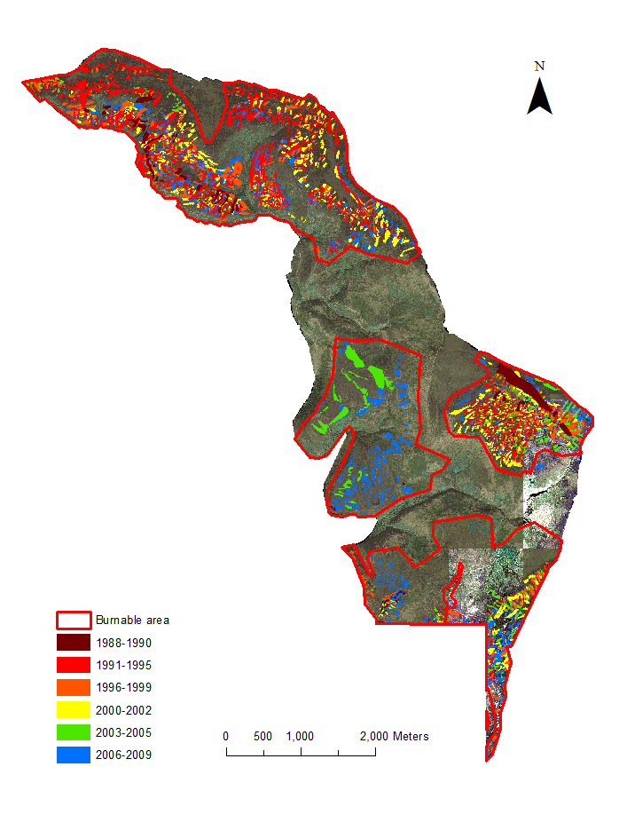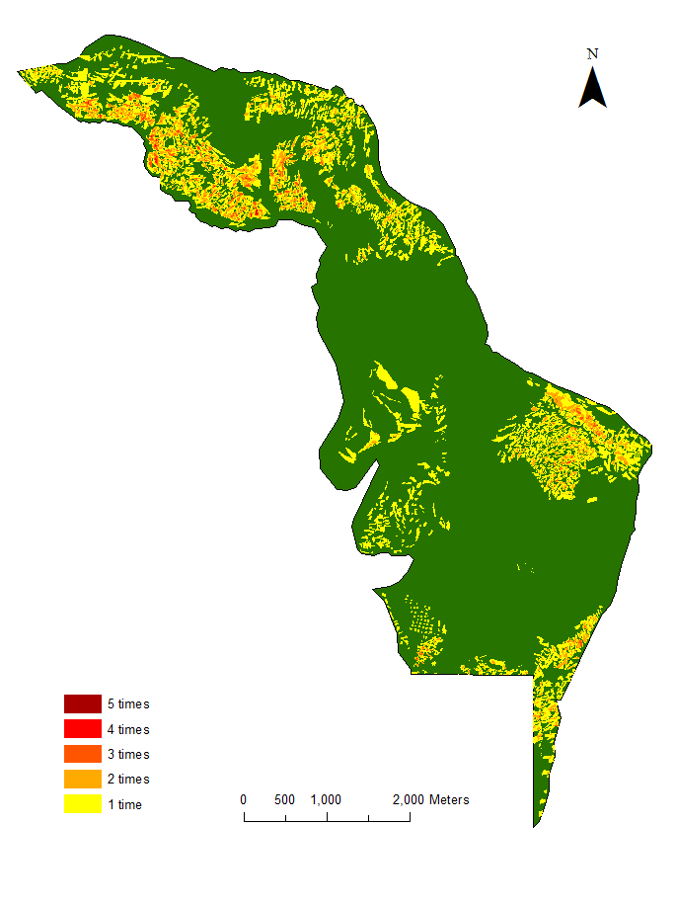
(b)
(a)

Fig .1. (a) Maps of prescribed burn patches on Howden Moor, Peak District between 1988-2009, overlain on aerial photography. B) Patches burned one, two, three, four and five times during the study period; green areas were not burned.

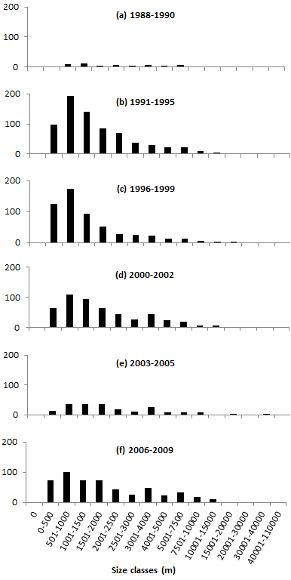
Number of burns

Fig. 2. Number of burn patches by size class on five sampling occasions

