Press Release
For Immediate Release – 8th September 2025

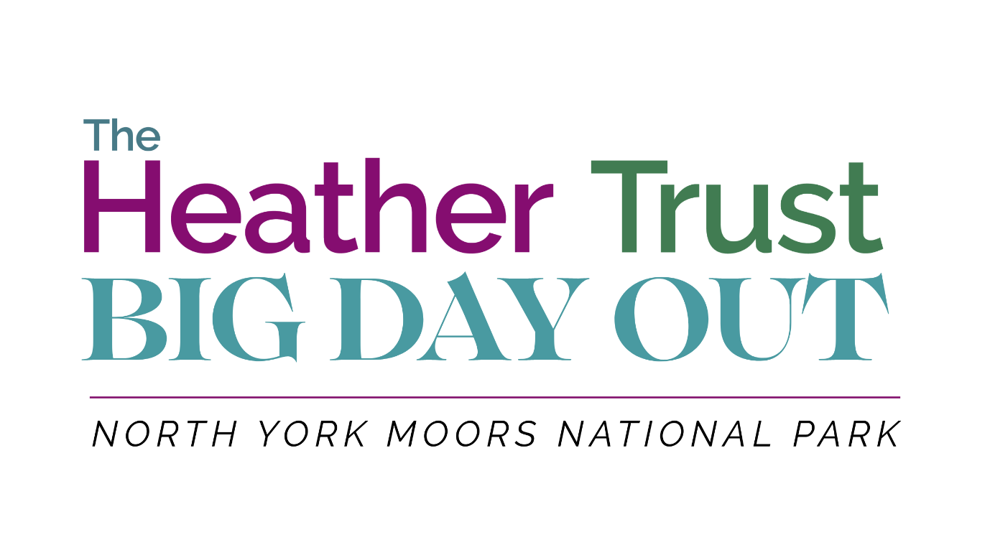

Charity’s “Big Day Out” to tackle the big issues affecting our uplands
The Heather Trust is bringing together some of the country’s leading voices in upland management, conservation, and moorland restoration for its Big Day Out in the North York Moors on Thursday the 18th of September 2025.
At a time when our uplands face unprecedented pressures — from wildfire risk and climate change to tick control, habitat loss and increasing legislation - this event offers a unique chance to hear from those at the forefront of tackling these many challenges. With contributions from academics, practitioners, conservationists, and land managers, the day promises to be as informative as it is inspiring with a focus on open discussion and knowledge-sharing.
Delegates will begin the day in Goathland Village Hall with presentations from speakers including Dr Andreas Heinemeyer of the University of York, renowned moorland regeneration pioneer Geoff Eyre, Rosie Snowden from the Yorkshire Peat Partnership and Matthew Colston, who will shed light on the growing problem of ticks and their impact on wildlife, livestock, and human health. They will be joined by voices from across the sector, including the North York Moors National Park, the National Gamekeepers Association, and The Heather Trust itself.
The morning presentations will be followed by a guided moorland walk on the stunning moorland plateau, offering the chance to see issues and solutions in action on the ground, before returning for lunch and an afternoon of discussion, debate, and Q&A. By combining scientific insight, practical expertise, and policy perspectives, the event will not only shine a light on the most pressing topics facing our uplands but also explore workable, sustainable solutions for the future.
Katrina Candy, Director of The Heather Trust, said:
“The Big Day Out is about bringing people together. Our uplands are iconic landscapes that matter to us all — for biodiversity, carbon storage, water management, and rural livelihoods. This event offers a rare opportunity to hear directly from those who are shaping the future of these landscapes and to be part of the conversation about how we manage them sustainably.”
Tickets are priced at £60 for Heather Trust members and £75 for non-members. With places limited, early booking is advised.
Book your place here → The Heather Trust’s Big Day Out | The Heather Trust

ENDS
For more information and media invitations, please contact:
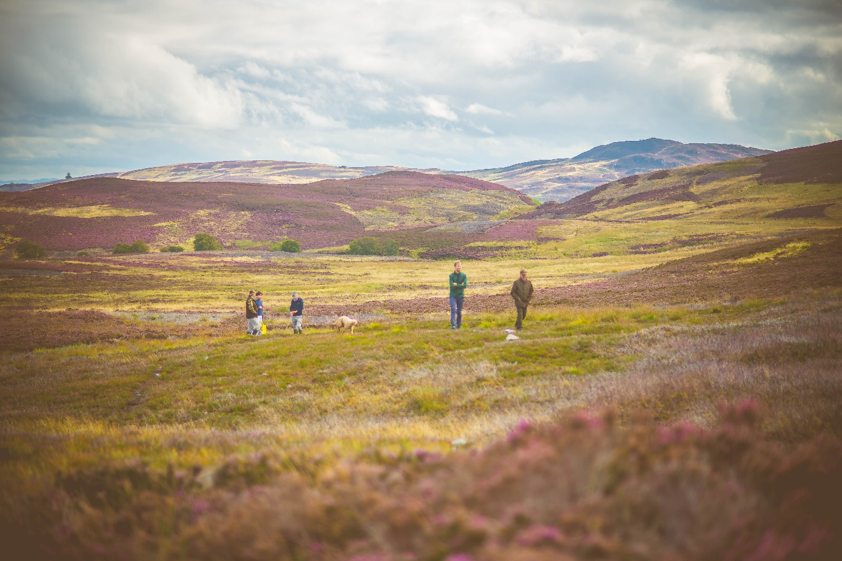
Press Contact:
Chloe Thornton
Marketing, Events & Digital Manager
The Heather Trust
E: chloe.thornton@heathertrust.co.uk | 07824638009

